Vendor Quick Reference Guide
VSBE Certification/Recertification

Overview
This Quick Reference Guide (QRG) shows you how to apply for the Veteran-Owned Small Business Enterprise (VSBE) Certification and recertify in eMMA, once you’re registered.
IMPORTANT!! Complete your annual recertification process, click this link to skip directly to that section: VSBE Recertification. Otherwise follow the first process below.
NOTE: For best results, access eMMA using the Google Chrome browser.
If you need help with eMMA at any point, please email the eMMA Help Desk at emma.helpdesk@maryland.gov.
For additional assistance with the certification or recertification process, contact Danielle Davis at danielle.davis2@maryland.gov or (443) 346-0717.

Prerequisites
In addition to this online application process, participation in Maryland's VSBE Program requires:
- The VSBE Veteran Verification Form to be completed along with acceptable veteran supporting documentation saved to your computer, for review by the Maryland Department of Veterans Affairs, or
- The Federal Vets First Center for Verification and Evaluation (CVE) certification through the U.S. Department of Veterans Affairs.
If you meet the other eligibility standards for this procurement program, you will remain in pending status until your vendor profile is updated with a Veteran Verification or Federal Vets First CVE number.
Find instructions for completing the Veteran verification process on the Governor’s Office of Small, Minority, and Women’s Business Affairs website, at https://gomdsmallbiz.maryland.gov/Pages/default.aspx.
PRO TIP: You can find your VSBE information in a public Vendor Search on the eMMA login page, once approved.
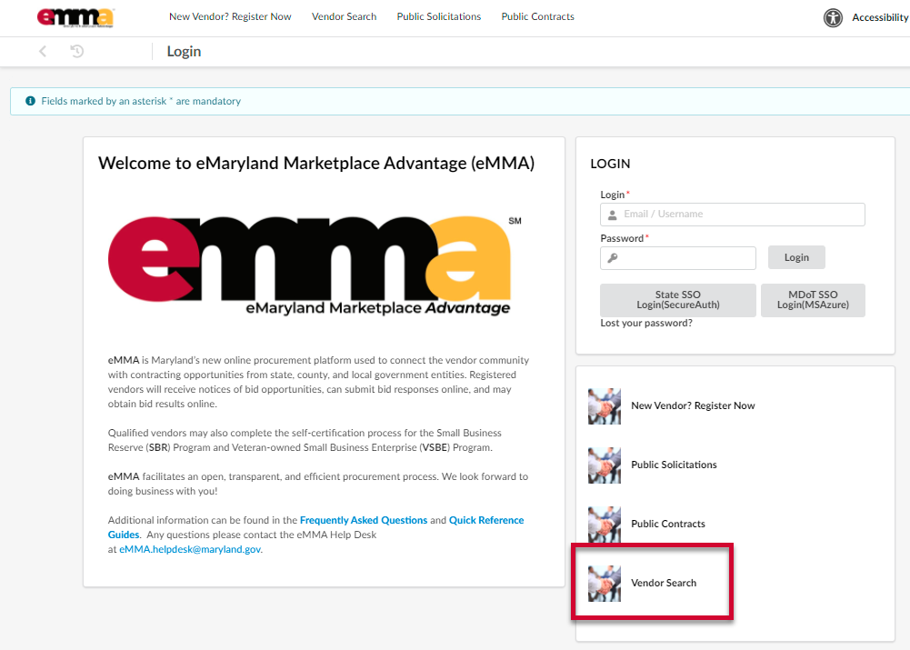

Step-By-Step Instructions

VSBE Certification
NOTE: This QRG uses diagrams with specific callouts to show required and optional fields in forms. A yellow callout with a red border indicates a required field, while yellow callouts with a black border indicate optional fields. Letters within the callouts correspond to the explanations below the diagram.
- Navigate to eMMA at https://emma.maryland.gov and log in with your credentials.
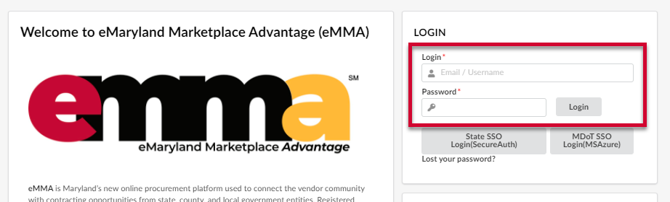
- Click General Info tab at the top of the webpage and click on the Company Profile option from the drop-down menu.
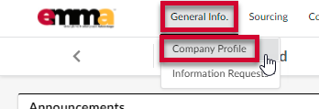
- Scroll down to the State Programs section, under Is your company currently enrolled in the following programs?
NOTE: The Veteran-Owned Small Business Enterprise (VSBE) field displays the No selection by default. Do not change it.
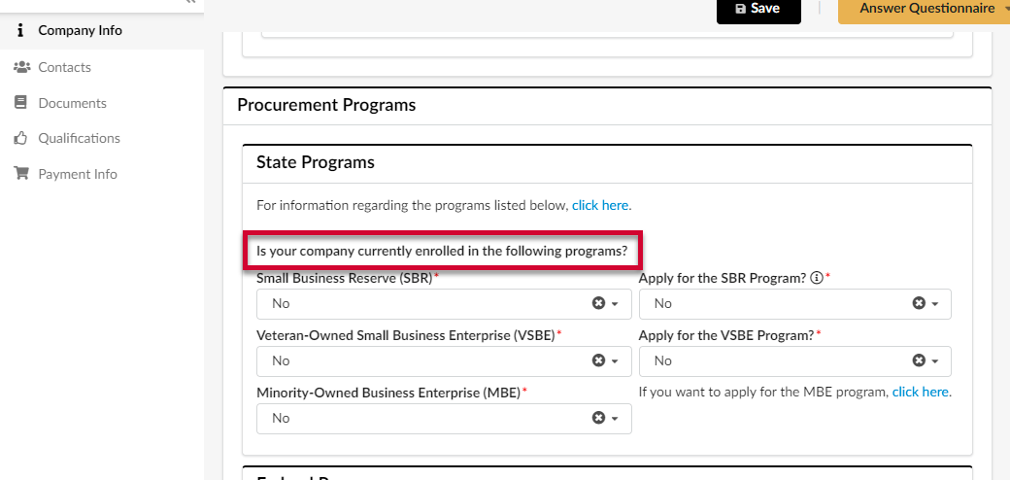
- Click the Apply for the VSBE Program? field and select Yes from the drop-down menu that opens.
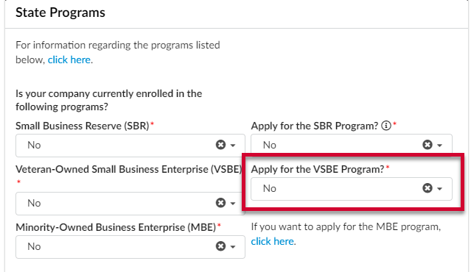
- Click the Save button at the top of the webpage.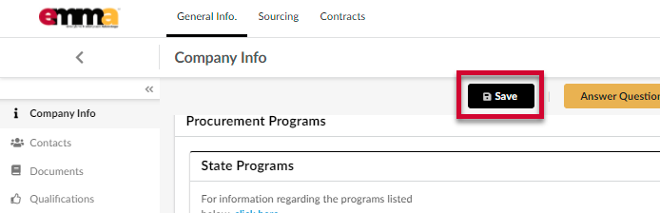
- Navigate to the Documents tab on the left-hand side-panel and scroll down to the Attestations & General Documents section. The VSBE application displays in a pink row with red lettering.
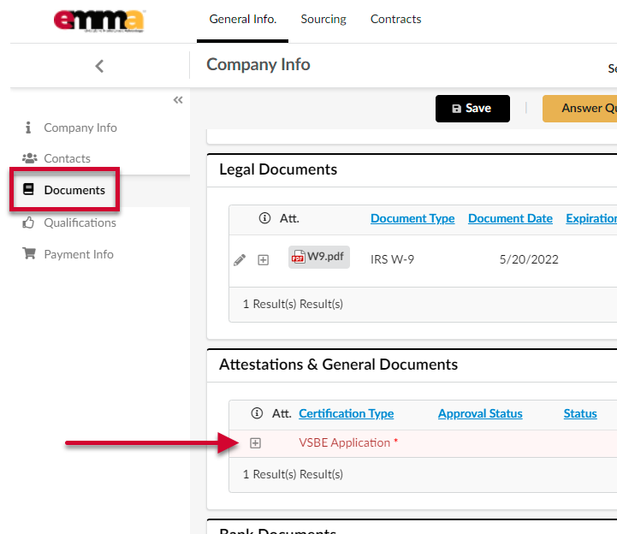
- Click the Add (plus) icon to the far left of the VSBE Application. A pop up window displays with form fields (the application).
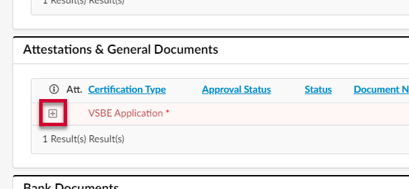
IMPORTANT!! Only click the plus icon ONCE! Clicking this icon multiple times creates multiple applications that will not be processed. Only your initial application will be processed. A notification of a duplicate application will display at the top of the webpage and in your email. Please check Spam and Junk folders if you don’t see the notification in your Inbox.
PRO TIP: Once you start your application, you can save it and come back to finish it later. You can find the document when you first log into your profile under My To-Do List on the homepage, or in the Documents tab of your Company Profile (General Info>Company Profile>Documents tab). Click the Edit (pencil) icon to the left of the document to edit the application.
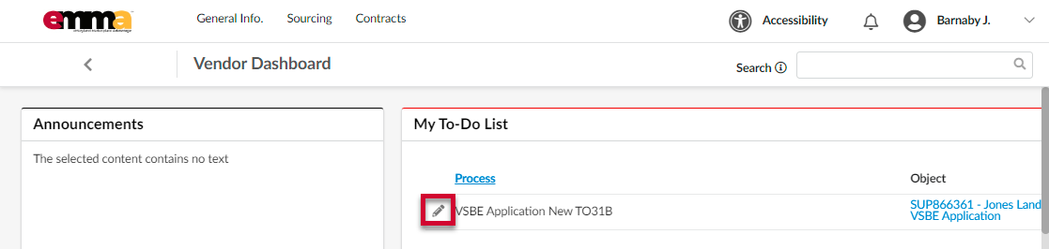
- (Optional) Click the first link at the top of the form to request veteran verification from the Maryland Department of Veteran Affairs.
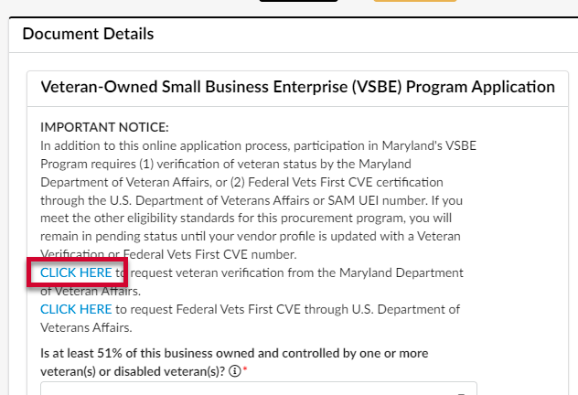
- (Optional) Click the second link at the top of the form to request Federal Vets First CVE through U.S. Department of Veterans Affairs.
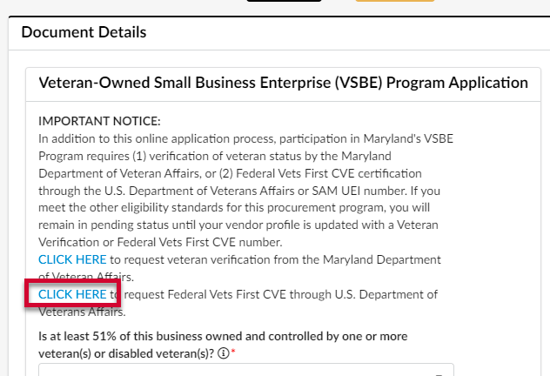
- Complete all required fields marked with a red asterisk (*).
NOTE: Hover your cursor over the tooltips for additional information regarding the field.
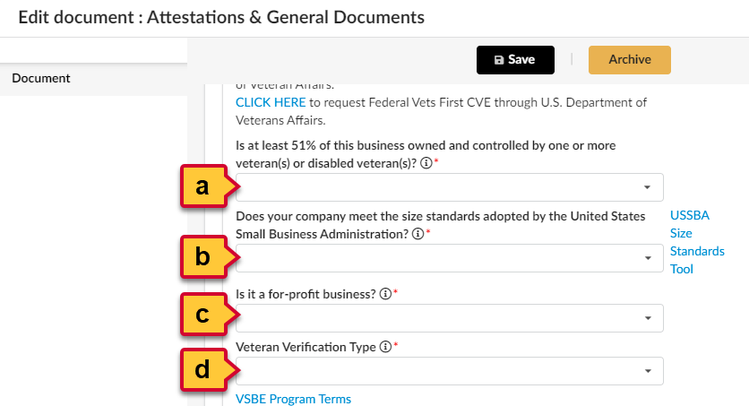
  - Is at least 51% of this business owned and controlled by one or more veteran(s) or disabled veteran(s)? (*): Click the field below to open the drop-down menu and select Yes or No.
TOOL TIP: If you answer “no” to this question, you will not qualify for the program.
  - Does your company meet the size standards adopted by the United States Small Business Administration?(*): Click the field below to open the drop-down menu and select Yes or No.
TOOL TIP: If you answer “no” to this question, you will not qualify for the program.
NOTE: If you are unsure, click the link to the right of this field for information regarding the USSBA Size Standards Tool. You may need to scroll horizontally to see this link.
  - Is it a for-profit business? (*): Click the field below to open the drop-down menu and select Yes or No.
TOOL TIP: If you answer “no” to this question, you will not qualify for the program.
  - Veteran Verification Type (*): Click the field below to open the drop-down menu and select an option from the list;
TOOL TIP: Select your veteran verification type and enter the specific number assigned to the business. You can obtain your veteran verification from one of two sources: (1) the Maryland Department of Veterans Affairs, or (2) the Federal Vets First Verification Program. It is not necessary to obtain veteran verification from both.
If you have not obtained your veteran verification, complete instructions can be found online at https://gomdsmallbiz.maryland.gov/Pages/VSBE-Program.aspx
    - First Time MD Veteran Verification: Use this option if you have not previously verified your Veteran status with the State of Maryland. If you select this option, the window refreshes and a non-editable field displays. You must upload both the Veteran Verification form and supporting veteran status documentation. Acceptable supporting documentation includes DD214, or DD215, (discharge papers or corrections to discharge papers). Steps 1-6 (below the tool tip here) show you how to upload these documents.
TOOL TIP: The Maryland Department of Veteran Affairs performs the state’s veteran verification process. Veterans seeking verification for the first time are required to upload a minimum of two documents: (1) the Veteran Verification Form, and (2) an acceptable veteran status document issued by the United States Department of Veterans Affairs.
The verification form and instructions can be found online at https://gomdsmallbiz.maryland.gov/Pages/VSBE-Program.aspx.
If you are unable to upload documents, contact Danielle Davis for assistance at danielle.davis2@maryland.gov or (443) 346-0717.
Upon verification, the vendor is issued a 12-digit veteran verification number, consisting of letters, numbers and one special character (Example: MDVA2020-099). You will not need to re-verify your veteran status once approved.
      - Click the Click or Drag to add a file button and select your Veteran Verification Form to upload it. You can also drag-and-drop the file over this button to add it.
NOTE: You cannot upload documents over 300,000 KB in size.
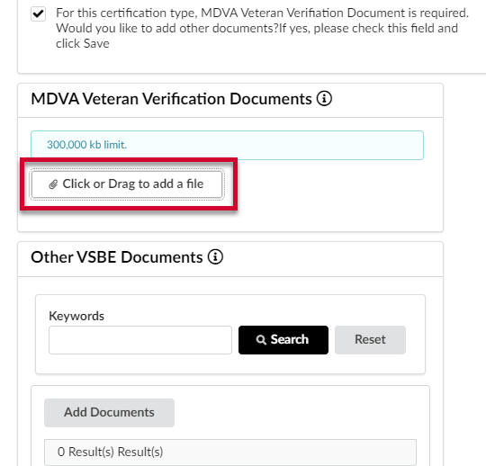
A thumbnail description of the uploaded document displays below this button.
      - Click the Save button at the top of the Edit Documents: Attestations & General Documents window.
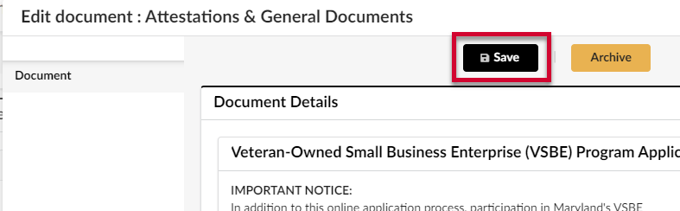
      - Select the second checkbox below the MDVA field and click the Save button at the top of the Edit Documents: Attestations & General Documents window. A new section displays below to let you add documents.
IMPORTANT!! You must click the Save button after clicking this checkbox. The new section will not display until you click Save.
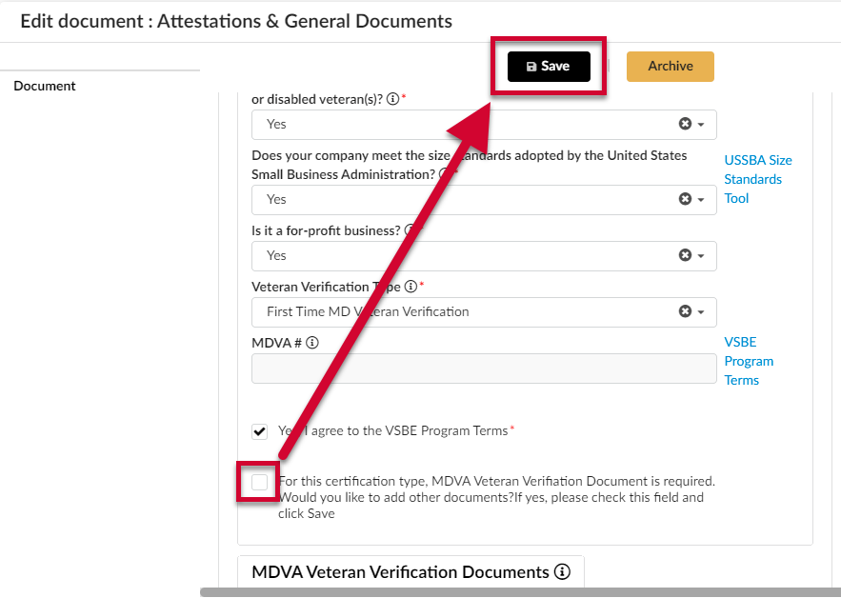
      - Click the Add Documents button, in the Other VSBE Documents section. A new window opens.
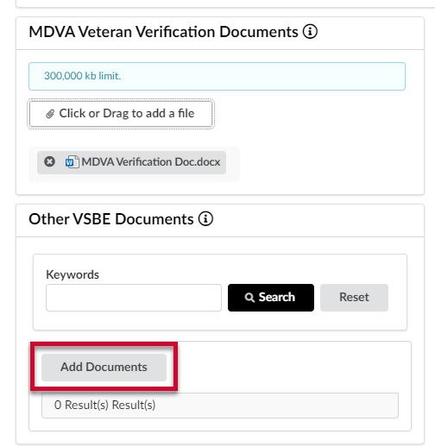
PRO TIP: If you have multiple documents uploaded here, you can use the Keywords field and Search button to find documents quickly.
      - Complete the required fields shown in the diagram and listed below. A red asterisk (*) indicates a required field.
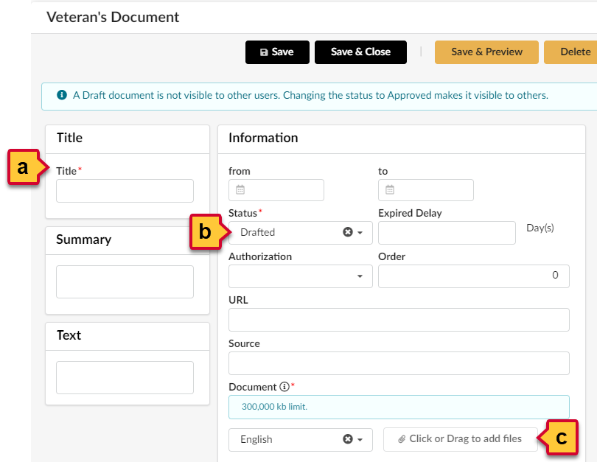
        - Enter a title for your supporting document in the Title field.
        - Click the Status field and select the Approved option from the drop-down menu that opens.
IMPORTANT!! You must set the status of your added document to Approved. This lets the approving parties review your document.
        - Click the Click or Drag to add a file button and select your supporting document to upload it. You can also drag-and-drop the file over this button to add it. A thumbnail description of the uploaded document displays below this button.
NOTE: You cannot upload documents over 300,000 KB in size.
      - Click the Save & Close button at the top of the Edit Documents: Attestations & General Documents window.
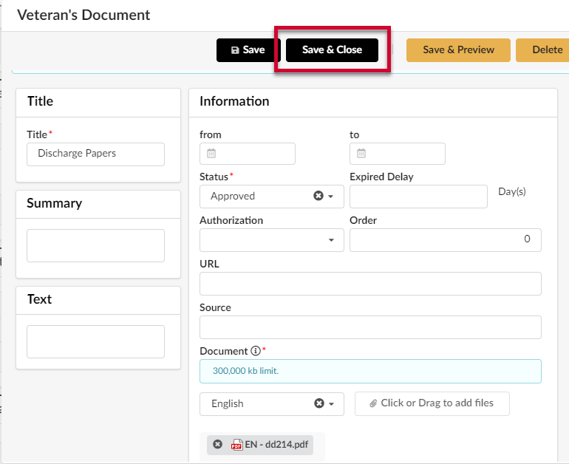
The added supporting document displays in the Other VSBE Documents section.
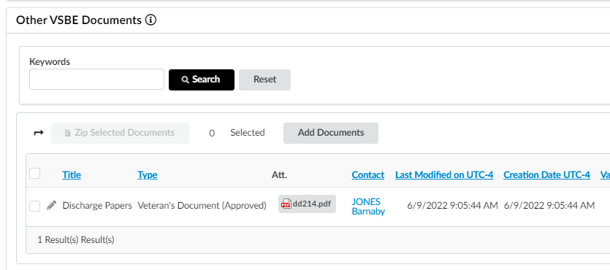
NOTE: If you need to delete the document and upload a new one, click the Edit (pencil) icon to the left of the document title. A new window opens. Click the Edit button at the top of the window. The Delete button displays at the top of the window. Click it to remove the document.
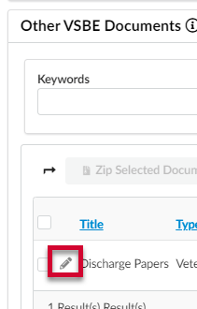

    - Federal Veteran Verification: If you select this option, a new field displays below. Enter your CVE number in the Vets First CVE field.
TOOL TIP: The Federal Vets First Verification Program is conducted by the Center for Verification and Evaluation. Vendors that have already obtained their Vets First verification will enter the SAM UEI (Unique Entity Identification) number assigned to the business. It is 12 digits, consisting of both letters and numbers (Example: ABC123DE45F6).
    - Existing Veteran Verification (Renewal): See the VSBE Recertification section below for instructions.

- Click the VSBE Program Terms link, below the fields or to the side of the last fields you entered. A new window opens.
NOTE: You may need to scroll horizontally to see this link.
- Review the VSBE Program Terms and return to eMMA.
- Select the checkbox for Yes, I agree to the VSBE Program Terms.
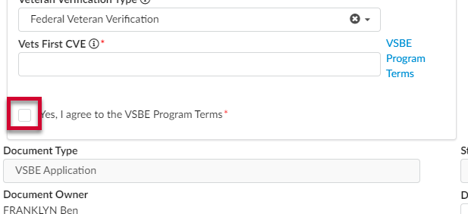
- Click the Save button at the top of the window.
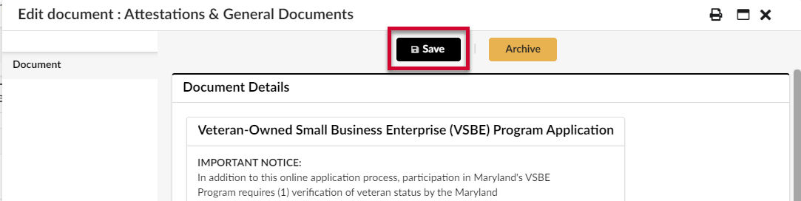
- Click the Submit Application button at the top of the window. A prompt displays asking you to confirm submission. Click the OK button in the prompt.
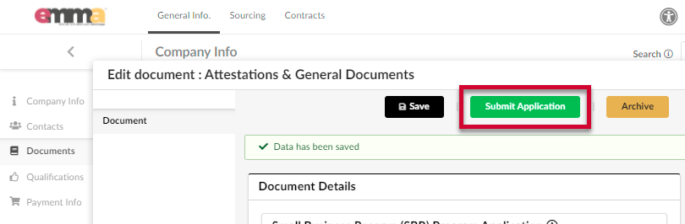
A notification banner displays below the Save button to indicate a successful or unsuccessful submission.
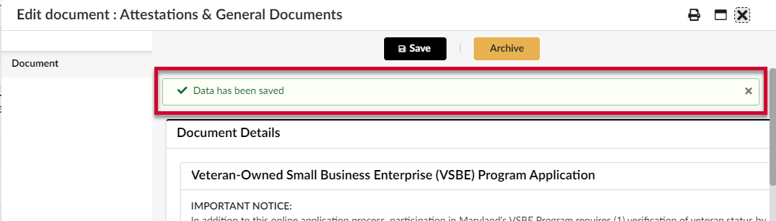
After submitting the application, close out of the form. If you meet the eligibility standards for this procurement program, you will remain in pending status until your Vendor profile is updated with a Veteran Verification or Federal Vets First CVE number. You will find approval information within the Documents tab (which is located on the left-hand side-panel). Scroll down to the Attestations & General Documents section to see your pending status.
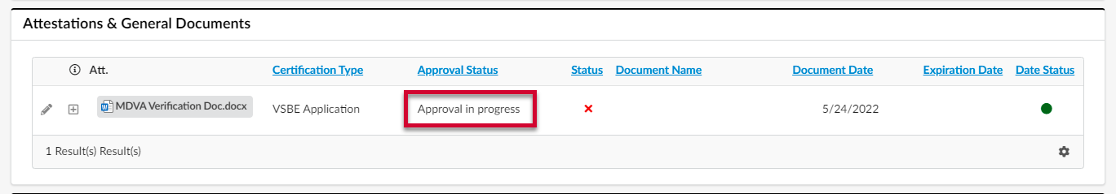
Once approved, the Attestations & General Documents section shows your approved application status and the expiration date.
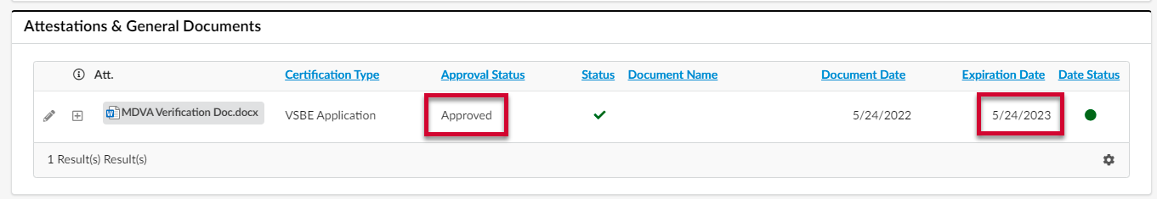
NOTE: A notice will display on your Company Info page in eMMA when your VSBE certification is 30 days from expiration. The 30-day VSBE Application Expiring Notification goes to any Vendor user that has the Vendor Admin profile. You must renew within this 30-day window or else your certification will expire. If you submit a renewal application prior this 30-day window, it will not be processed.
Once approved, eMMA will also update your Vendor profile in the Company Info section to reflect your certification number under the State Programs section. You will receive an email notification regarding your approval or found non-compliant status. Please check your Spam or Junk folders if you do not see this email in your Inbox.
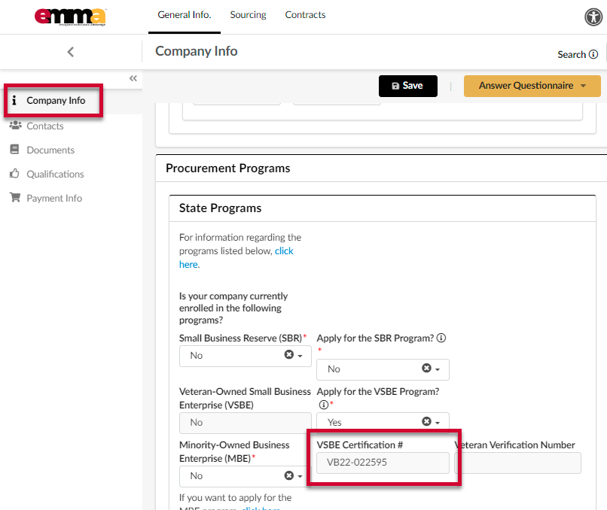

VSBE Recertification
IMPORTANT: Please make sure you read all the instructions before starting this process.
Only vendors with a VSBE Certification # (VBXX-XXXXXX) are eligible for the recertification process. This number is shown under your Company Info tab in your eMMA profile under procurement programs. If you have any questions regarding your recertification, you can contact Danielle Davis for assistance at danielle.davis2@maryland.gov or (443) 346-0717.
NOTE: A notice will display on your Company Info page in eMMA when your VSBE certification is 30 days from expiration. The 30-day VSBE Application Expiring Notification goes to any Vendor user that has the Vendor Admin profile. You must renew within this 30-day window or else your certification will expire. If you submit a renewal application prior this 30-day window, it will not be processed.
- Click the Documents tab on the left-hand side-panel.
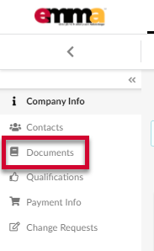
- Scroll down to the Attestations & General Documents section and click the Add (plus sign) icon to the far left of the VSBE Application. A pop-up window displays with form fields (the application).
NOTE: Do NOT click the pencil icon. Only the plus sign icon will create a new form for your renewal.
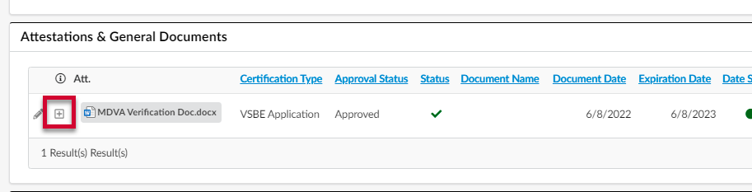
IMPORTANT!! Only click the plus icon ONCE! Clicking this icon multiple times creates multiple applications that will not be processed. Only your initial application will be processed. A notification of a duplicate application will display at the top of the webpage and in your email. Please check Spam and Junk folders if you don’t see the notification in your Inbox.
- Complete all required fields marked with a red asterisk (*).
NOTE: Hover your cursor over the tooltips for additional information regarding the field.
  - Is at least 51% of this business owned and controlled by one or more veteran(s) or disabled veteran(s)? (*): Click the field below to open the drop-down menu and select Yes or No.
TOOL TIP: If you answer “no” to this question, you will not qualify for the program.
  - Does your company meet the size standards adopted by the United States Small Business Administration?(*): Click the field below to open the drop-down menu and select Yes or No.
TOOL TIP: If you answer “no” to this question, you will not qualify for the program.
NOTE: If you are unsure, click the link to the right of this field for information regarding the USSBA Size Standards Tool. You may need to scroll horizontally to see this link.
  - Is it a for-profit business? (*): Click the field below to open the drop-down menu and select Yes or No.
TOOL TIP: If you answer “no” to this question, you will not qualify for the program.
  - Veteran Verification Type (*): Click the field below to open the drop-down menu and select the Existing Veteran Verification (Renewal) option from the list. Two new fields display.
TOOL TIP: Select your veteran verification type and enter the specific number assigned to the business. You can obtain your veteran verification from one of two sources: (1) the Maryland Department of Veterans Affairs, or (2) the Federal Vets First Verification Program. It is not necessary to obtain veteran verification from both.
If you have not obtained your veteran verification, complete instructions can be found online at https://gomdsmallbiz.maryland.gov/Pages/VSBE-Program.aspx
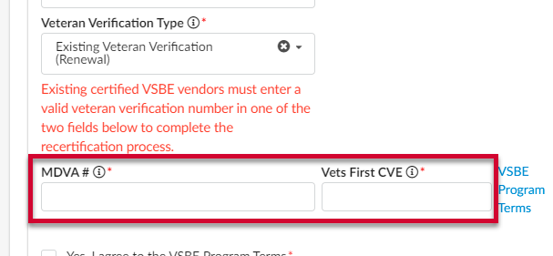
      - MDVA #
TOOL TIP: Renewal for the VSBE Program is an annual process. Enter the veteran verification number issued to the company by the MDVA.
      - Vets First CVE
TOOL TIP: Renewal for the VSBE Program is an annual process. Enter your active Federal Vets First Verification Program number (i.e. SAM UEI).
- Click the Save button at the top of the window.
NOTE: If you have questions before you submit your application, contact Danielle Davis at danielle.davis2@maryland.gov or (443) 346-0717.
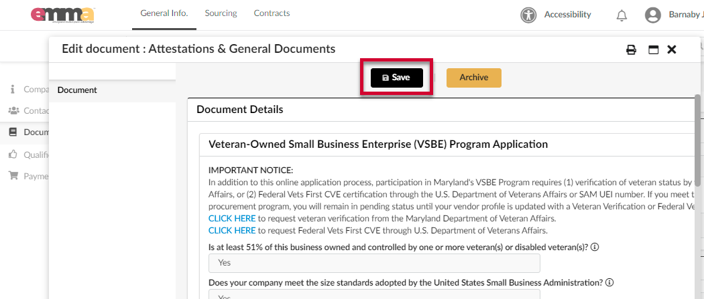
- Click the Submit Application button at the top of the window. A prompt displays asking you to confirm submission. Click the OK button in the prompt.
A notification banner displays below the Save button to indicate a successful or unsuccessful submission.

NOTE: eMMA will automatically set a new Expiration Date. The Date Status will show as a red dot in the Documents section of your vendor profile until validated, at which point it becomes green. In the image below the first line represents the current VSBE certification (close to expiration). The second line represents the renewed application. Notice that it is Approved but the Date Status has the red dot which will remain until the application is validated.
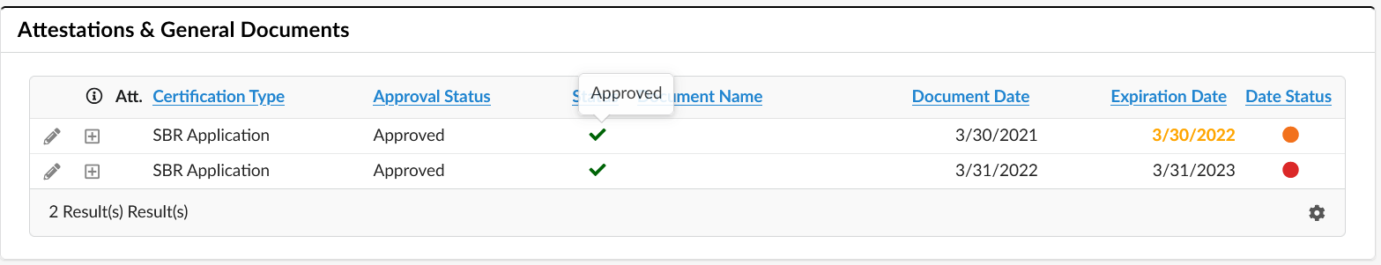
NOTE: Failure to recertify by your expiration date will automatically result in removal from the VSBE Program. However, if your certification expires, you can submit a new application. If you are found eligible for the program, a new VSBE Certification number will be issued.

For additional assistance with the recertification process, contact Danielle Davis at danielle.davis2@maryland.gov or (443) 346-0717.

