VSBE REPORTING MANUAL

Prepared by Governor’s Office of Small, Minority & Women Business Affairs

July 1, 2022
Table of Contents

VSBE Program Overview 3
VSBE Liaisons-NEW 3
VSBE Internal Compliance 3
VSBE Reporting 3
VSBE Reporting Format 4
VSBE Data Collection 5
Backup Data 6
VSBE Annual Report 7
Contact Emails 8

VSBE Program Overview

The Veteran-Owned Small Business Enterprise (VSBE) Program, enacted in 2010, requires State agencies to spend a minimum of 1% of the total dollar value of agency procurement contracts directly or indirectly with veteran-owned small businesses (State Finance & Procurement Article, §14-206, Annotated Code of Maryland). Veteran business ownership status is determined by size standards adopted by the United States Small Business Administration in 13 C.F.R. 121.201 and whether at least 51% of the for-profit business is owned by one or more individuals who are veterans that control the management and daily operations of the business (§14-601 and added §14-606, State Finance & Procurement Article, Annotated Code of Maryland).

Effective October 1, 2018, legislative action assigned oversight of the VSBE Program to the Governor’s Office of Small, Minority & Women Business Affairs (GOSBA) (COMAR 21.11.14.04 d). Participating agencies and departments are now required to submit annual performance data to GOSBA.

VSBE Liaisons - NEW

Each participating agency/department is required to name a VSBE liaison officer in the administrations of the agency’s VSBE Program. The VSBE liaison officer is responsible for coordinating outreach efforts to the veteran business community, reviewing agency contracting procedures to ensure compliance, assisting in the resolution of contracting issues, and for submitting required VSBE Program reports or information. (COMAR 21.11.14.05).

VSBE Internal Compliance

The contract owner should monitor and track VSBE compliance on a monthly or quarterly basis, and individual contract utilization should proceed in accordance with the Utilization Affidavit and Participation Schedule submitted when the contract was awarded (COMAR 21.11.14.06 & COMAR 21.11.14.11). Internal compliance data does not have to be submitted to GOSBA unless requested.

VSBE Reporting

All participating agencies are required to submit their individual VSBE Reports to the GOSBA on or before the close of business on October 1, 2022 (COMAR 21.13.01.15).

Data collection methods, data exclusions, and other pertinent information for reporting VSBE data are consistent with those provided in the MBE Reporting Manual (Delegated Contracts: Page 6).
This report manual may be used as a guideline in preparing the VSBE Report:

- Data from the 700 series reports from ANSWERS, or captured in an internal database, should be used to report both award and payment data on the VSBE Annual Report.

- All figures reported on the annual report should be backed up with auditable data.

- If contracts have both a VSBE prime and subcontractor, do not double count. Report the VSBE award and payment under the prime contractor only

- At this time, VSBE credit card payments cannot be tracked in ANSWERS. Agencies will have to track these payments manually.

- GOSBA will provide technical assistance and support for VSBE reporting. Contact danielle.davis2@maryland.gov or call 443.346.0717 if assistance is needed.

VSBE Reporting Format

- The latest VSBE Annual Report Template will be available from GOSBA beginning July 1st. Only the latest template should be used to submit the VSBE Annual Report. This ensures that any changes are captured.

- The VSBE template should be submitted in Excel Format. Questions concerning the template should be submitted to danielle.davis2@maryland.gov.

- All supporting backup data should be emailed to vsbereports.gosba@maryland.gov.

GOSBA will submit a compiled VSBE Annual Report for publication to the Governor and the Legislative Policy Committee. If your agency does not comply, it is reported as “non-responsive.”

VSBE Data Collection

Agencies will use the following reports to collect AWARD and PAYMENT data from ANSWERS (https://net.md.gov/apps/answers/):
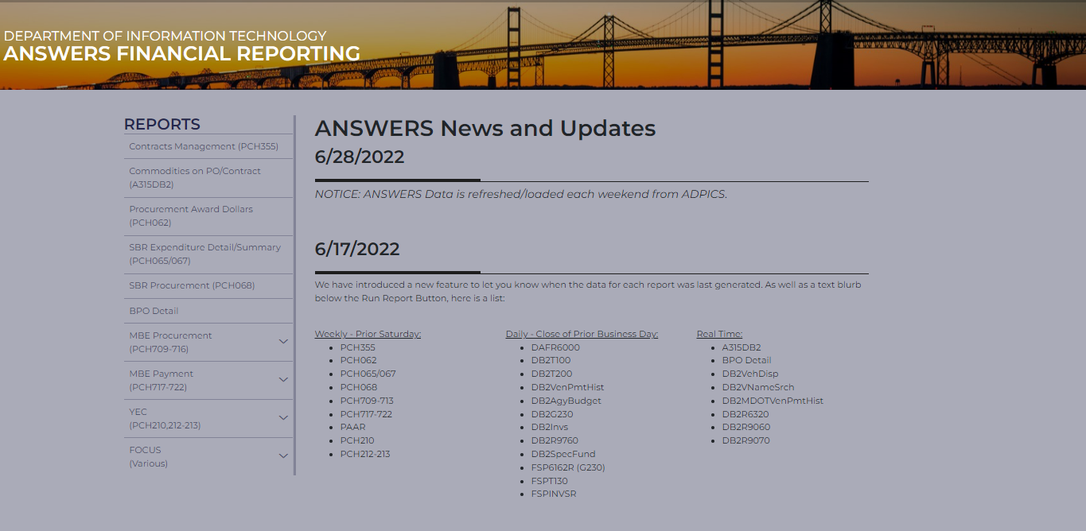

You will have to change the Report type to VET in answers, where appropriate.

AWARDS:

a) PCHL709 (BPO/PO Change Orders from contracts awarded in prior fiscal years)
b) PCHL710 (Contract Awards Detail) run by award date
c) PCHL717 (VSBE Prime Payments by Direct Voucher; no BPO/PO)*
d) PCHL720 (VSBE Subcontract Awards) run by award date

Outside of ANSWERS, you must report
e) Manually tracked Credit Card payments*

PAYMENTS:

a) PCHL717 (VSBE Prime Payments by Direct Voucher; no BPO/PO)*
b) PCHL718 (VSBE Prime Voucher Payments made from BPO/PO)
c) PCHL719 (VSBE Subcontractor Payments)

Outside of ANSWERS, you must report
d) Manually tracked Credit Card payments*

*PCHL 717 and Credit Card Payments are reported as both payments and awards.

FMIS CHEAT SHEET

AWARDS = ANSWER reports 709, 710, 717, 720 & 721 OR VIEW DIRECT A30USB11

PAYMENTS = ANSWER reports 717, 718, 719 & 721 OR VIEW DIRECT A30USB11

Reminder: Direct Vouchers and P-card purchases* are reported as both AWARDS and PAYMENTS.

*With the exception of control agency/department statewide contracts

Tips

The purpose of reporting is to evidence the State of Maryland’s commitment to procuring goods and services from veterans. Non-procurement items should not be included in agencies’ reports. (Refer to COMAR 21.01.03.01 for items that are exempt from procurement reporting.)

- For a more complete list of exclusions visit http://GOSBA.maryland.gov/Pages/Reporting-Tool-MBE.aspx and download the GAD List Exclusion Definitions.

- Remember that use of non-delegated Statewide contracts is not reportable as awards; however, payments made on these contracts are reportable in the payments table on the VSBE Annual Report. (Rule of thumb: Awards – do not include awards made from Statewide Contracts; Payments – report all procurement payments, including payments on Statewide contracts.)

Backup Data

- 700 Series and Credit Card Reports should be scrubbed to remove all non-reportable items.

- All original and scrubbed reports should be added to one Excel Workbook on different tabs.

- The reports should be emailed along with the VSBE Annual Report as backup data.

VSBE Annual Report

Click to obtain the latest VSBE Annual Report or email danielle.davis2@maryland.gov.

VSBE Annual Report Template- Located with VSBE Toolkit

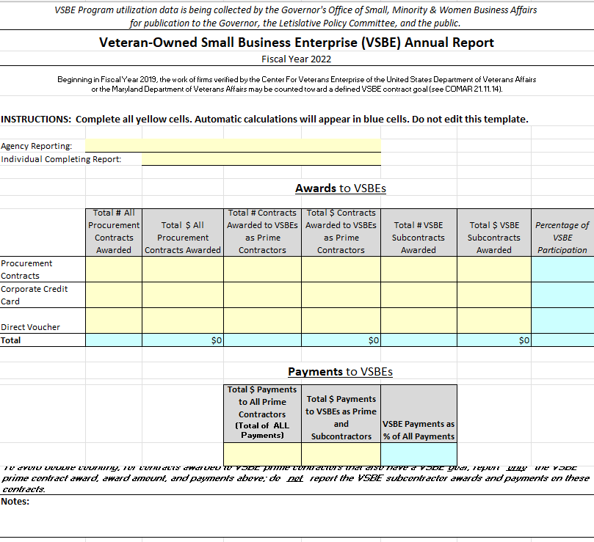

- All AWARDS columns require data for three different award types: Regular Procurement Contracts, Corporate Credit Card, and Direct Voucher Awards.
- The yellow cells indicate that data must be added, blue cells indicate that data is calculated, and these cells are protected.

Enter the data as follows

Row 7: Enter Agency name
Row 8: Enter report preparers name
Awards Column B: Count the total agency procurements for each award type and place the # here.
Awards Column C: Add the $ amounts of total agency procurements for each award type and place amount here
Award Column D: Count the total Contracts awarded to VSBE Primes for each award type and place the # here
Awards Column E: Add the $ amounts of total procurements awarded to VSBE Primes for each award time and place amount here
Awards Column F: Count the total procurements awarded to VSBE Subcontractors for each award type and place the # here
Awards Column G: Add the $ amounts of total procurements awarded to VSBE Subcontractors for each award type and place amount here

The VSBE participation % is calculated automatically.

PAYMENT columns only require data for two cells
Payment Cell D21: Total $ amounts paid to all Prime Contractors
Payment Cell E21: Total $ amounts paid to VSBE Prime and Subcontractors

The VSBE payment % is calculated automatically.

Contact Emails

Completed Annual Reports and Backup Data should be emailed to GOSBA by October 1st at vsbereports.gosba@maryland.gov.

General questions about the VSBE Program or reporting should be directed to VSBE Compliance Manager, Danielle Davis via email
Danielle.Davis2@maryland.gov or phone 443-346-0717.

